**Phases of Stock Price Prediction Model**

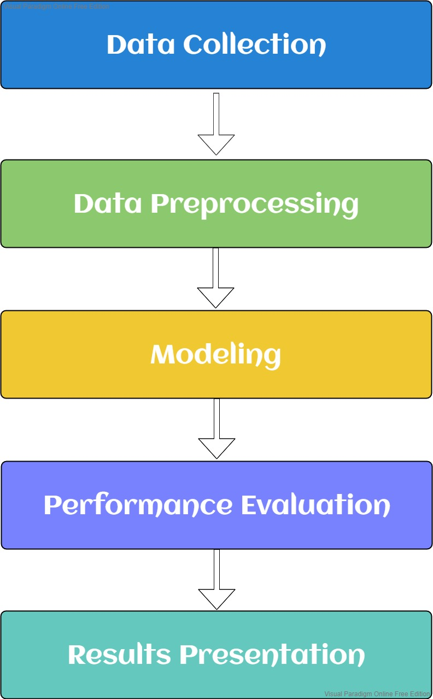

**Proposed Stock Prediction Framework**

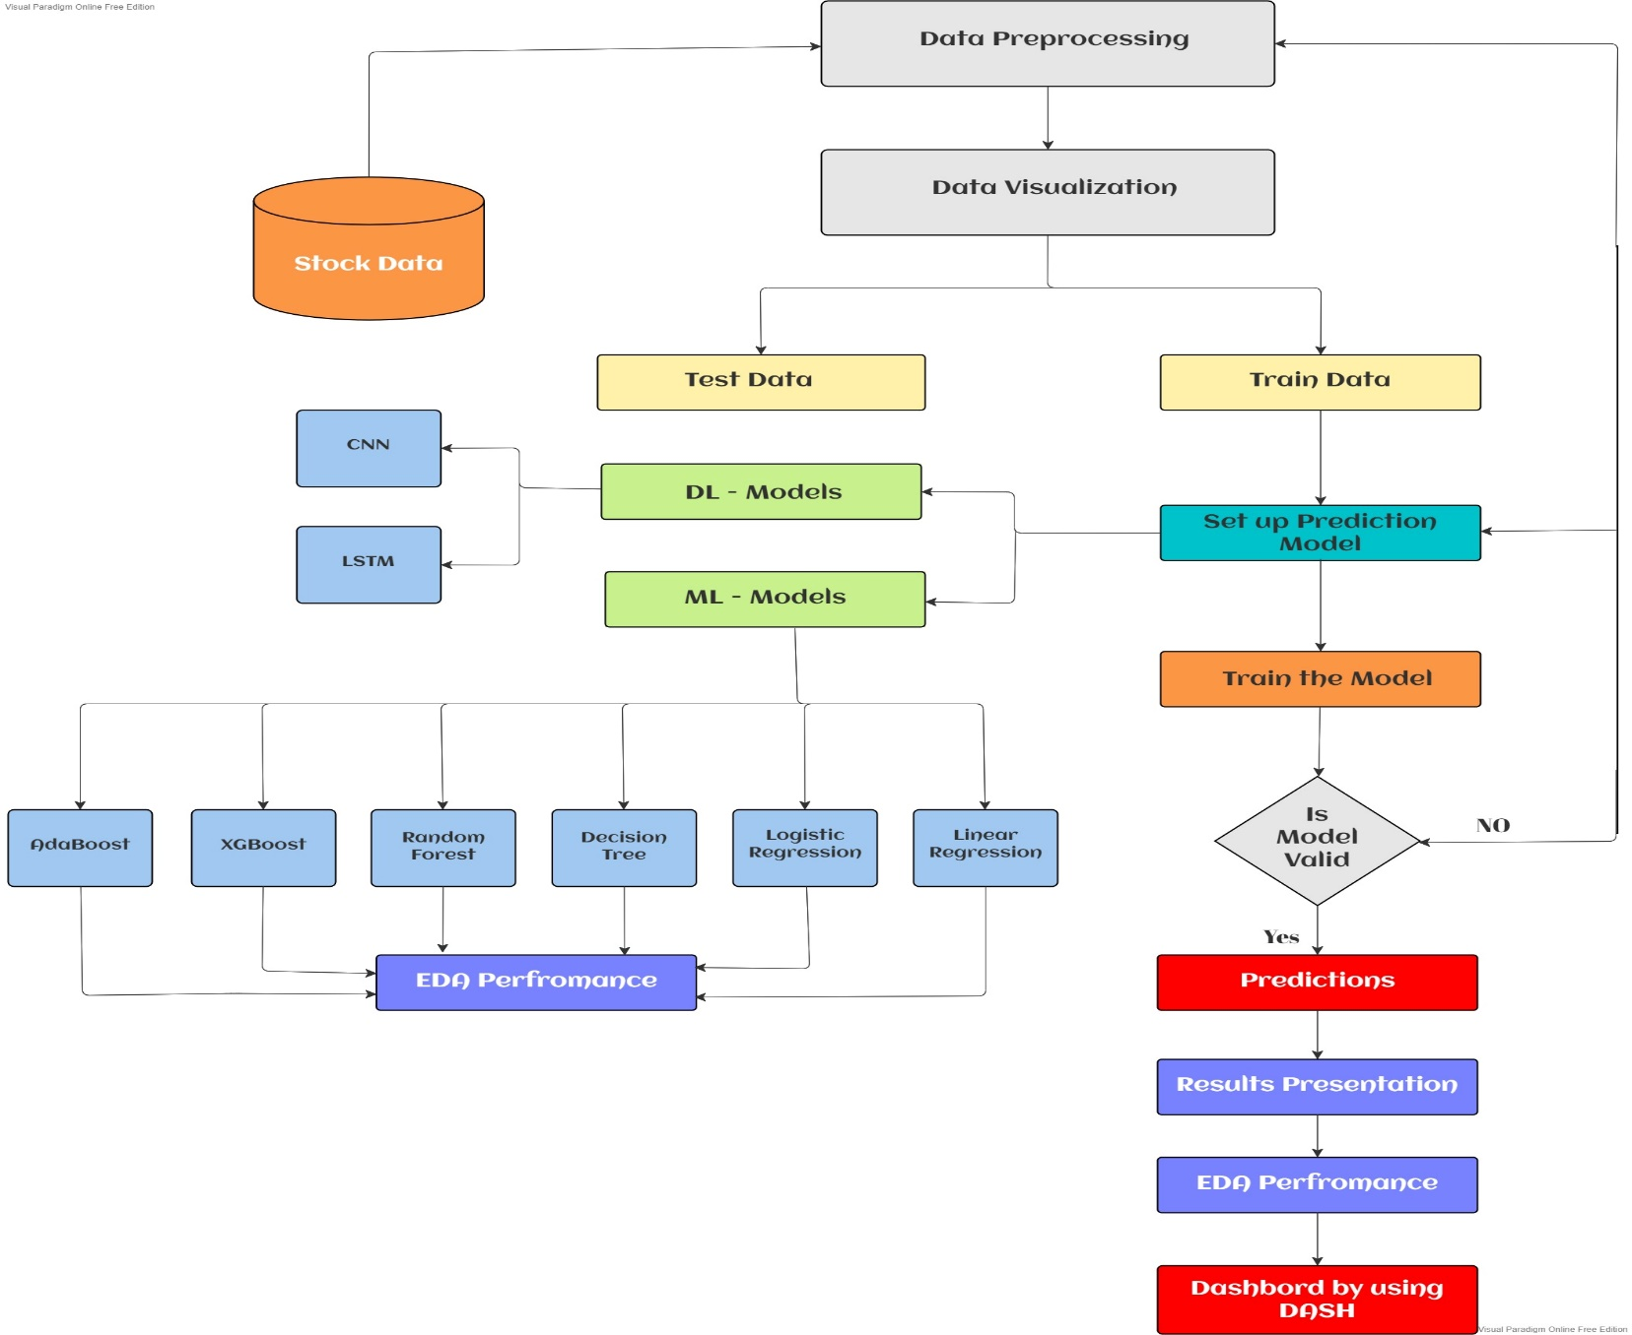

**Web Application Framework for Stock Trend Prediction by using Streamlit (Python Web App)**

Streamlit turns data scripts into shareable web apps

